Macs, EPPI Reviewer 4 and Firefox / Silverlight

NOTE: This only applies to **Mac OS 10.14 (Mojave) or earlier**. Macs upgraded to Catalina (macOS 10.15) will only run 64-bit applications and will not run the necessary Silverlight browser add-on.

If you are using macOS 10.15 (Catalina), please use ***EPPI Reviewer Web***. This runs on any modern browser and across devices, including smartphones and tablets. See our [website](https://eppi.ioe.ac.uk/cms/Default.aspx?tabid=2914) and [forum](https://eppi.ioe.ac.uk/cms/Default.aspx?tabid=2932&forumid=22&threadid=2266&scope=posts) for further details of ER-Web.

# Installing Firefox ESR v52.9.0

Download and install* Firefox ESR v52.9.0 from <https://archive.mozilla.org/pub/firefox/releases/52.9.0esr/mac/>. (The versions are organized in language. A full list of the language abbreviations used can be found at <http://www.lingoes.net/en/translator/langcode.htm> e.g. the Swedish version is at <https://archive.mozilla.org/pub/firefox/releases/52.9.0esr/win64/sv-SE/>.)

*NOTE – you may find that the installer checks for updates ***before*** installing. We advise you to disconnect from the internet after downloading the application, before you start the installation process. This will prevent the installer finding any updates online. You can do this via your System Preferences (or simply by removing your network cable / turning off Wi-Fi).

Once you have installed Firefox ESR v52.9.0, you will have to set it up in the correct manner, as described in the following section.

# Setting up Firefox ESR v52.9.0

1. Disable Updates - Note that you should disable updates for Firefox, to prevent your installation updating to another version that does not allow NPAPI plug-ins.
2. Select the ***Preferences*** Menu.

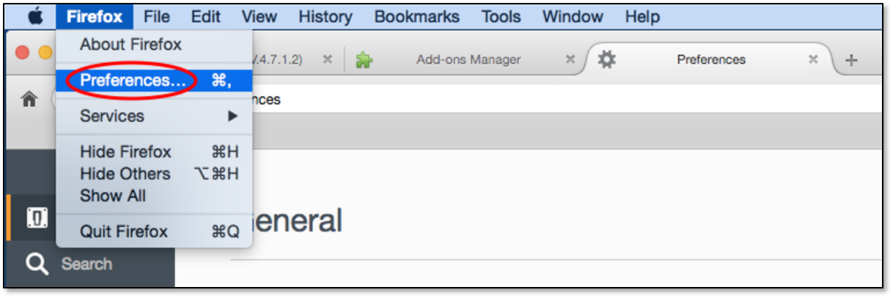

1. Select the ***Advanced*** section in the left-hand pane, and the ***Update*** tab in the right-hand pane. Then select ***Never check for updates***.

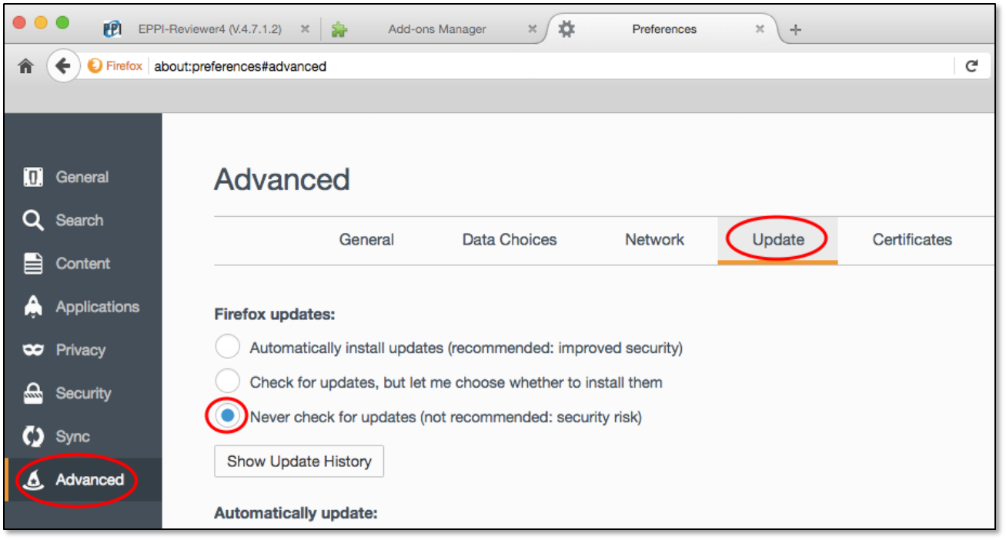

1. You will also need to install and enable the Microsoft Silverlight add-on, available from <https://www.microsoft.com/getsilverlight/Get-Started/Install/Default>.
2. Select the ***Add-ons*** menu from the ***Tools*** dropdown.

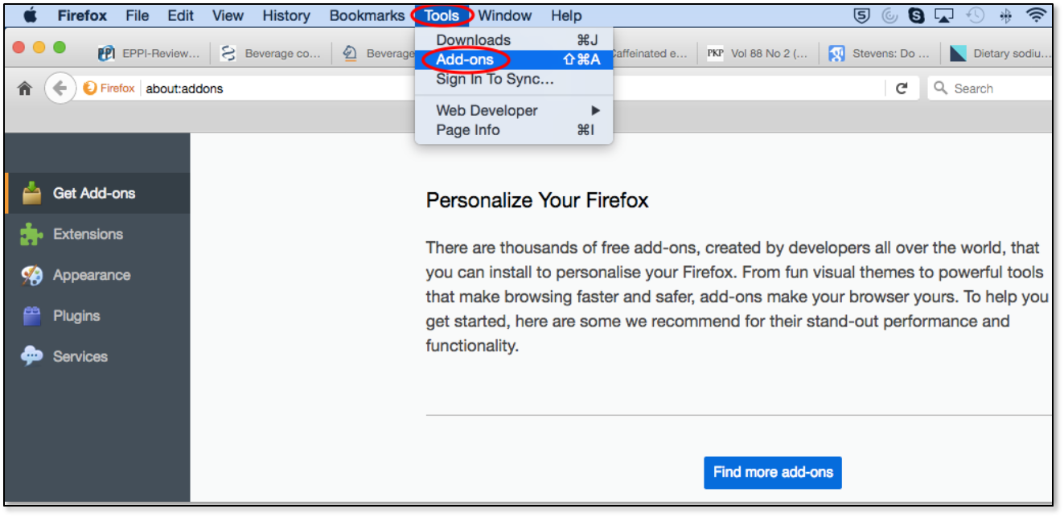

1. Select the Plug-Ins section in the left-hand pane of the screen.

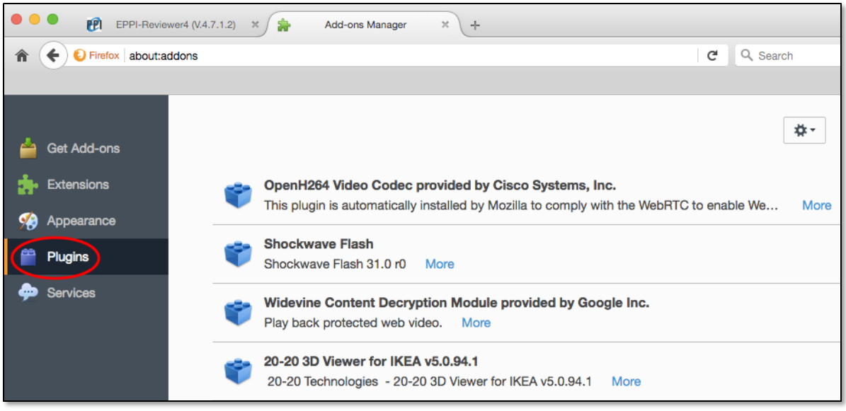

1. Scroll down to the Silverlight plug-in.

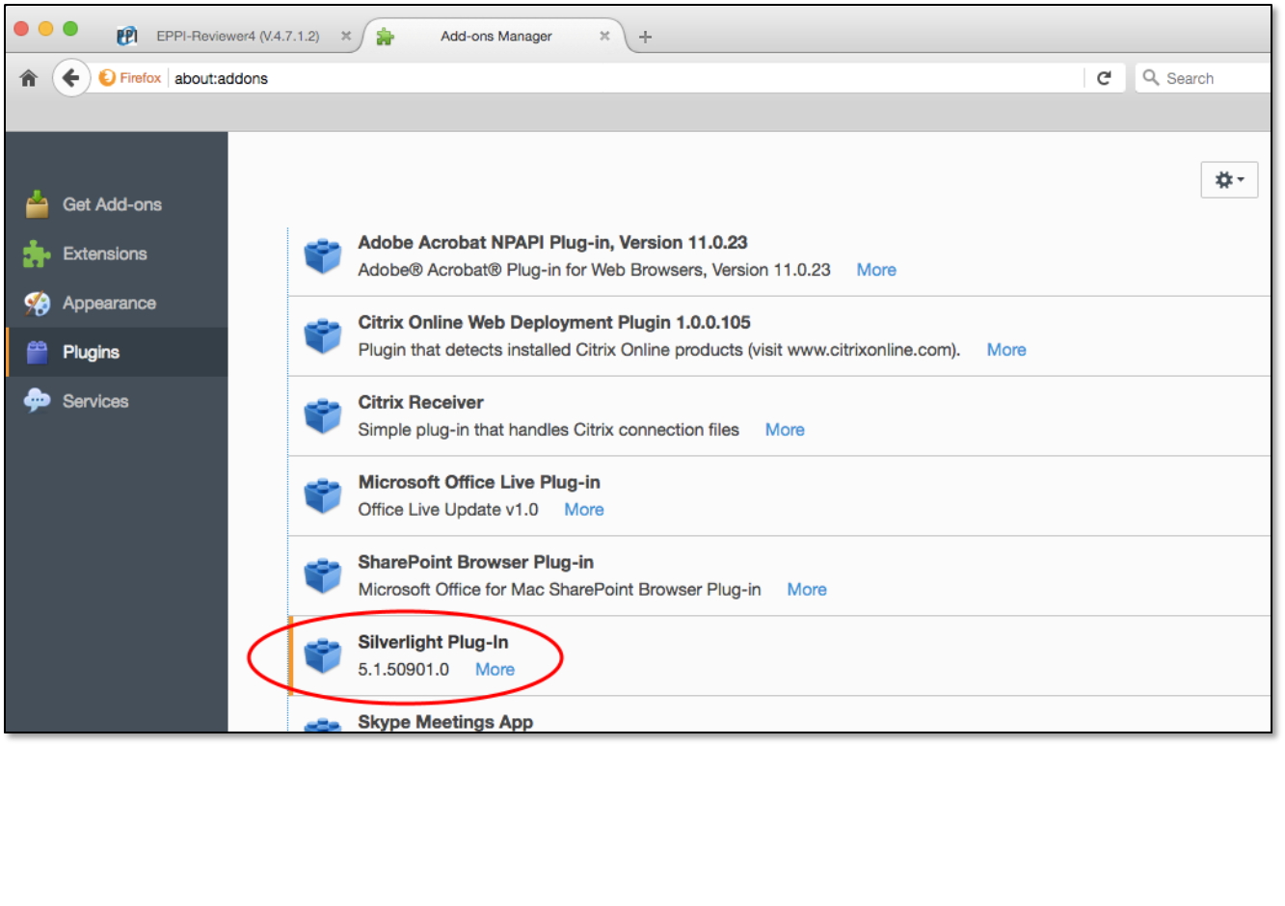

1. Set the plug-in to ***Always Activate***.

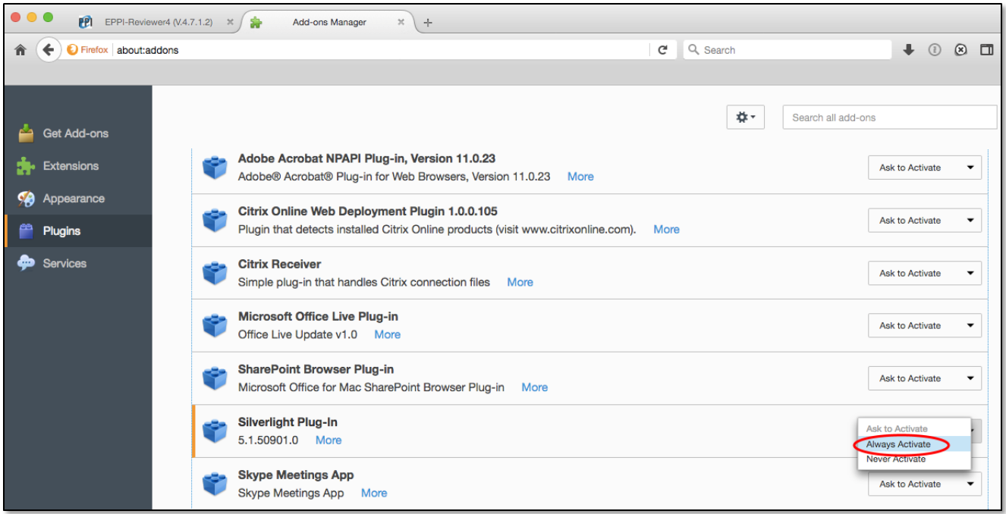

1. You should be able to test your Silverlight installation by visiting the following page -: <http://bubblemark.com/silverlight2.html>. You should see some bouncing green bubbles moving around the screen, as per the screenshot below.

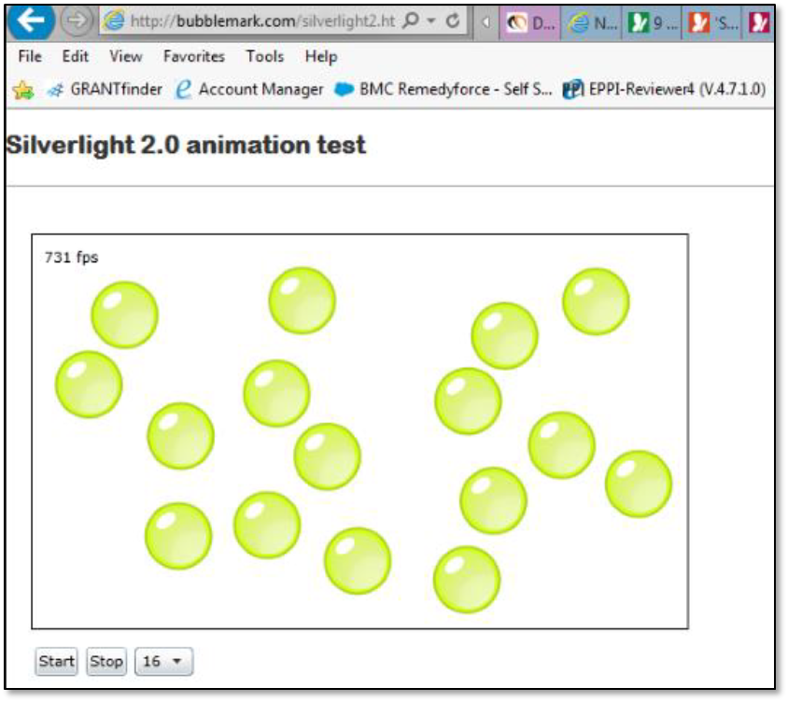

You should be able to now use EPPI Reviewer software successfully!

If you still experience issues getting ER 4 to work on your Mac, please email [eppisupport@ucl.ac.uk](mailto:eppisupport@ucl.ac.uk).

NOTE: You can use EPPI Reviewer Web on any modern browser and across devices, including smartphones and tablets, without the need for browser add-ons. Should you need any of the functionality not yet made available in the new version of EPPI Reviewer, you can always switch back to EPPI Reviewer 4, just to carry out that function, and then switch back to ER-Web. Both versions use the same underlying database and anything you do in one version will be reflected in the other. You cannot log on to both versions at the same time, as this could cause inconsistencies in the database, but you can switch between the two at will…

If all else fails, you can run ER4 on any Mac using the Chrome extension IE Tab. This allows you to emulate Internet Explorer within Chrome. You can download this at <https://chrome.google.com/webstore/detail/ie-tab/hehijbfgiekmjfkfjpbkbammjbdenadd>. Once installed, simply click the IE Tab icon in your Chrome browser and visit the ER4 URL.

NOTE: When you first start Firefox with the new profile, you will be prompted to sign in to Sync so that you can sync your data with the new profile. This feature allows you to store your favourites etc. in the cloud, so they are accessible wherever you use Firefox. You may not wish to avail yourself of this feature, especially in your Firefox ESR v52.9.0 installation used to run EPPI Reviewer 4. Simply ignore this prompt, if you do not wish the feature. If you already use Sync in another profile or device, enter the email address and password for your Firefox Account and your new profile will use those settings.

